Studio PDR Planning Worksheet
Objectives:
Outcome 1:
- Actively participate in meetings with the Product Owner for a good understanding of customer needs
- Use Design Thinking techniques to plan a user-centric project
- Use basic project management techniques to improve the workflow of an existing team project
Outcome 2:
- Release production code on a regular basis for a team project
- Attend regular team meetings and stay informed at all times
- Have an active presence on GitHub (backlog, kanban etc)
Name:Logan
Date of scheduled PDR meeting: Final
Discussed with:
What are your personal goals and objectives in addition to the course objectives?
This could be for Studio, BIT or general career progression
What has gone well this semester? What are your strengths?
What could have gone better and how? What would you do differently next time?
If you could replay the semester over again, what improvements would you make?
What are the next steps to take? What is your plan for further self-development?
Figure out a way to arrive earlier while still having enough sleep
What barriers to your success exist? How do you plan to deal with them?
Distance to and from Polytech. Money for food.
No clue how to deal with the first problem and I need to save more to deal with the other problem.
What is not clear or is uncertain?
In Studio, for BIT, at Polytech etc

What evidence do you plan to use to demonstrate your completion of the objectives?
(For the mid-semester PDR you will have only completed some of the objectives. Just bring evidence of those ones)
You must include:
- links,
- screengrabs and
- brief explanations
under each objective below. Keep in mind that this should be enough evidence for someone who doesn’t know you to be able to tell that you passed each objective (together with your lecturer’s observation notes).

1.1 Actively participate in meetings with the Product Owner for a good understanding of customer needs
Give examples of how you used these meetings to know what to build in your project. Show that you attended all meetings and didn’t just sit quietly in the corner.
After the meetings we took a transcript of everything the client said and placed it into our projects github wiki. Adding little links to go to specific parts of the meeting to help us make sure that we stayed on track with what the client wanted.
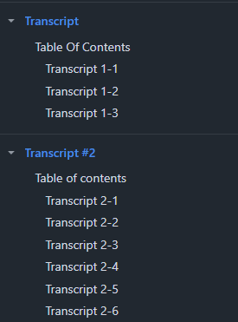

1.2 Use Design Thinking techniques to plan a user-centric project
Give examples that show how you used Empathise, Define, Ideate, Prototype, Test techniques to ensure the customers would get what they actually need.

We empathised with the client during the meeting asking questions to help us narrow down on what exactly the client wanted. We defined and ideated on what the client needed during our stand up meeting every day. And we prototyped and tested an entire website using github and teamwork.

1.3 Use basic project management techniques to improve the workflow of an existing team project
Demonstrate that you kept your team and Product Owner informed of the status and progress of all your tasks (must be more than just verbal) and that you helped with work distribution and delegation.
We frequently created and used lots of issues with tags to help us prioritise certain issues over others.
We also did frequent pull requests to staging to have a full environment to check how well the feature/ website works.
Here is the best pull request and all of the issue tags
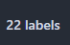
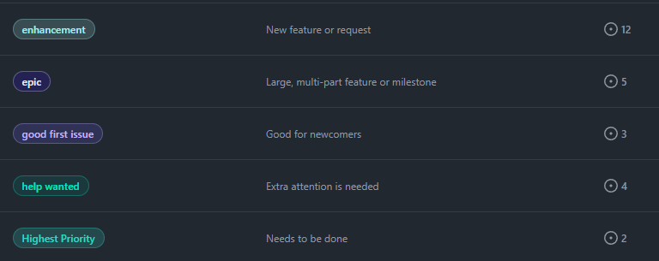
2.1 Release production code on a regular basis for a team project
Give examples of your code contributions that you’re most proud of. You’ll need to show code that’s at the level expected of a second-semester student, and demonstrate that you have contributed every week of the project time, including outside of scheduled class time.

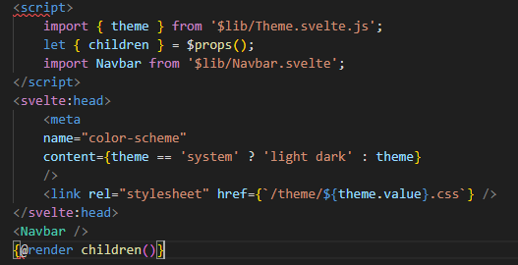
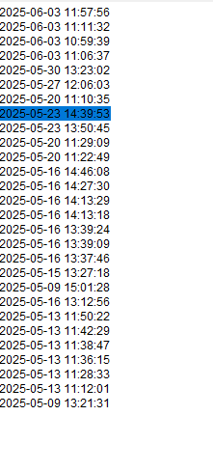

2.2 Attend regular team meetings to always stay informed
Your team must hold daily stand-up meetings so that every team member knows what every other member is doing. Show that this was happening (e.g. how was it organised?) and explain the outcome of doing this.
Any time anyone arrived at class we held a short stand-up meeting briefly going over who is going to do what this lesson.
This allowed each member to have a clear understanding of who is doing what that day and made sure that every member had something to do every class.
When we didn’t have a meeting we had a couple instances of people working on similar or even the same thing.

2.3 Have an active presence on GitHub
Demonstrate that you communicated well and often on GitHub: always made good Pull Requests for your features, wrote thorough code reviews, described Issues properly etc.
Issue text example
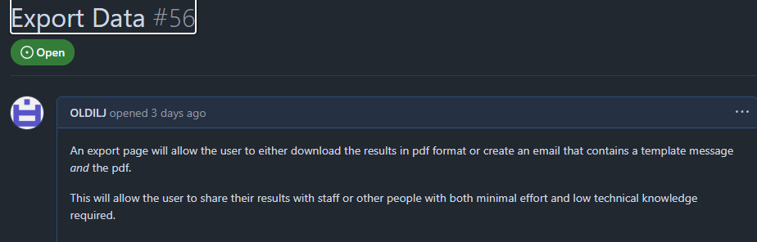
Total issues created
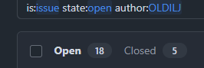
This is the total commits done
